Name:
MATTER
Has Weight and takes up Space

Word Bank

Classify
Conduct
Dissolve
Electric
Energy
Gas
Liquid
Magnetic
Matter
Observe
Property
Solid
Space
Weight

“What Am I” Games: Hedbanz and 20 questions

Hedbanz. Pick up a card with the playing face down. Put it in your headband without looking at the picture on the front. Then begin asking your partners questions.

20 questions. Think of an object and write it down but don’t show it. Then make your partners ask you yes or no questions in order to guess the object.

- Easy version- ask questions with one word answers about who you are such as “what color am I?” You must be specific. You can’t just ask “what do I look like?”

- Harder version- ask only yes or no questions such as “am I red?”

- Hardest version – ask only yes or no questions and also keep track of how many questions you have to ask to get the right answer. Try to use the fewest questions possible to find out what you are.

Sample questions:

Do I have legs?
Could I be a pet?
Can I swim?
Do I make noise?
Can I be eaten?
Do I have hair?
Can I be worn?
Can I fly?
Am I a vegetable?
Am I heavy?
Am I alive?

Observing Matter Part 1: Using our Five Senses

 | See  Color  Shape  Size | Touch 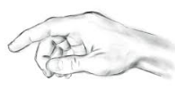  Texture  Temperature  Hardness | 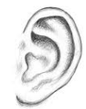  Hear  Volume  Tone | Taste 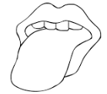  Sour, bitter, sweet, salty | Smell  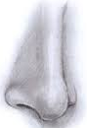  Flowery, stinky, citrusy,

Observing Matter Part 2

Object: | Does it bend? 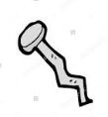 | Does it stick to a magnet? 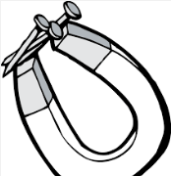 | Does it heat up easily?  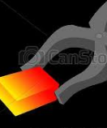 | Does the lightbulb light up? 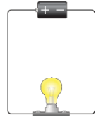 | Does it float? 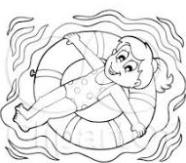 | Does it disappear when stirred in water?  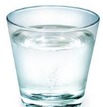

Using Properties to Sort Matter

- Choose your bag of objects
- Decide what properties you will use to sort the objects
- Sort them into piles
- Then take a picture of your piles

Solid, Liquid, Gas
Solid | Liquid | Gas
States of Matter: Demonstration of Changing States

Solid | Liquid | Gas

Is it a solid or liquid?

Which Ball Bounces the Highest?
 | Rubber | Cork and Leather | Sponge | Plastic
Trial 1
Trial 2
Trial 3
Trial 4
Best bounce overall

Ball Bounce Graph

No Melting Popsicles

Matter Poem

Reversible and Irreversible Changes

 | Heating | Cooling | R or I
Ice cube
Chocolate chips
Crayons
Egg
Dough
Salt Water

Each group will pick one to describe their evidence that the change caused by heating or cooling is reversible or irreversible.

An Object made of small pieces can be disassembled and made into a new object.

You are what you eat

​1.1.N Classify various foods into appropriate food groups. 1.2.N Identify the number of servings of food from each food group that a child needs daily. 1.3.N Discuss the benefits of eating a nutritious breakfast every day. 1.4.N List the benefits of healthy eating (including beverages and snacks). 1.5.N Describe the benefits of drinking water in amounts consistent with current research- based health guidelines. 1.6.N Describe how to keep food safe from harmful germs. 1.7.N Identify a variety of healthy snacks. 1.8.N Identify and explore opportunities outside of school for regular participation in physical activity. 1.9.N Explain how both physical activity and eating habits can affect a person’s he

