The Reason for The Seasons Model
Instructions for creating your Model
You are going to create a picture and description that demonstrates how the relationship between the earth and sun causes the seasons. You will use your model to explain to someone else about the cause of the seasons. You model should demonstrate the facts about the Earth that have been provided. Your model should include a title, an explanation, labels and arrows. Be sure to draw the earth’s axis and label the direction that it is pointing. Also include a picture of the Earth during each of the four seasons. Describe the limitations of the model. (For example - the sun is too big compared to the Earth – you could line up 109 Earths across the face of the sun. So your model cannot be to scale.) You may choose to cut and paste the following images if you would like. You can shade in areas to indicate darkness.

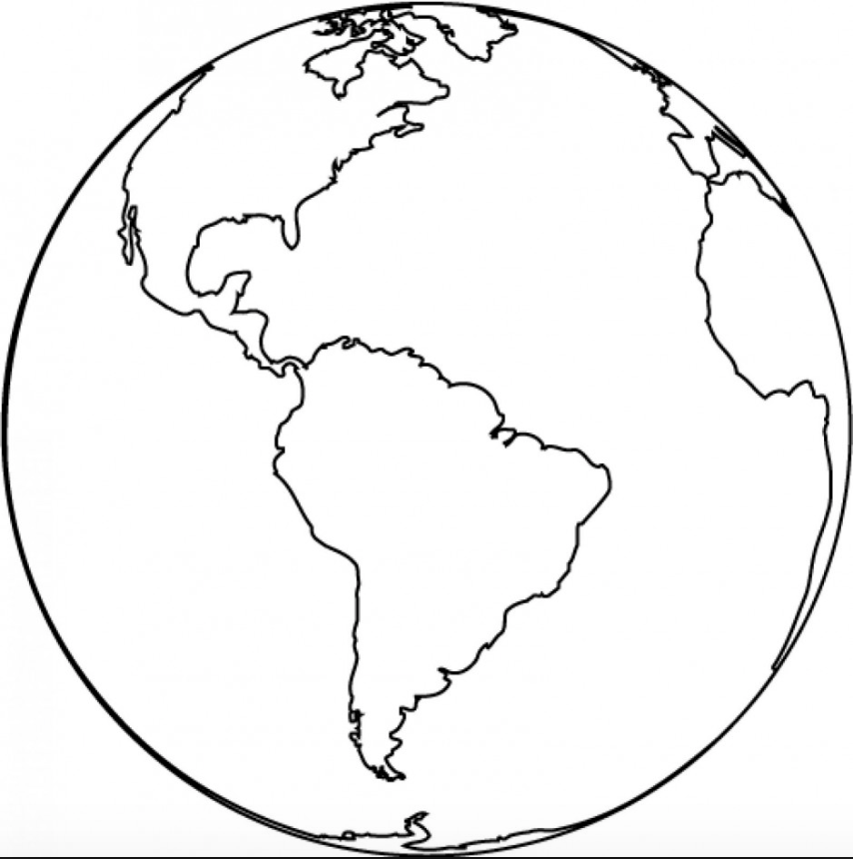
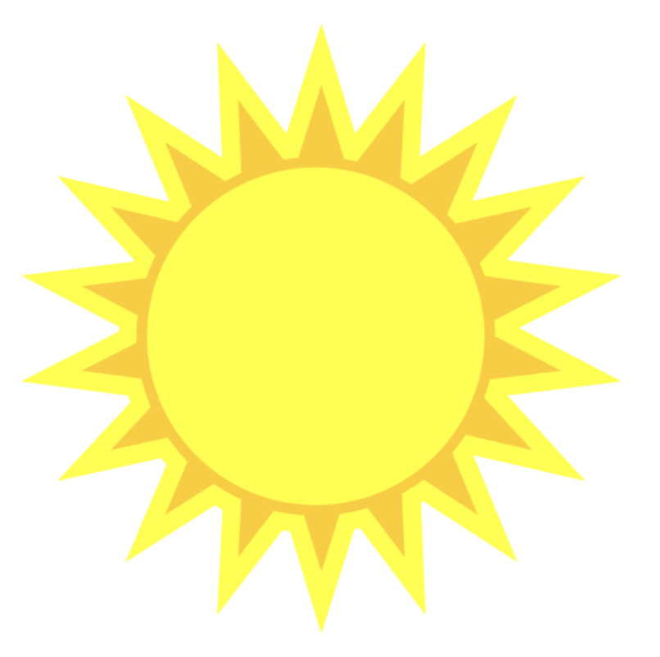
Title:

Explanation:

Limitations of Model:
Spring Equinox March 20

Summer Solstice June 21

Fall Equinox September 23

Winter Solstice December 21

Earth Facts
Please read all of them before beginning your model.
1. The earth’s axis is tilted 23.5 degrees with the North Pole directing towards Polaris (the North star).
2. The Earth orbits the Sun.
3. It takes the Earth about 365.25 days to complete its orbit around the Sun in a counterclockwise direction. (Every four years we have a leap year on February 29 to make up for the fact that a year is actually 365 and ¼ days long.
4. The earth takes about 24 hours to completely rotate on its axis in a counterclockwise direction.
5. In the Northern Hemisphere the Winter Solstice which is the shortest day of the year is around December 21. (This is the Summer Solstice for the Southern Hemisphere.) At the North Pole there is a period of time in the late fall and early winter when the sun never rises and it is dark all day and all night.
6. In the Northern Hemisphere the Summer Solstice which is the longest day of the year is around June 21. (In the Southern Hemisphere this is the Winter Solstice.) At the North Pole there is a time in summer when the sun never sets and it is light all day and night.
7. In the Northern Hemisphere the Fall (Autumnal) Equinox in which the day and night are equal is around September 23.
8. The Spring (Vernal) Equinox in which day and night are equal is around March 20.
9. The earth’s orbit is very slightly elliptical and is closest to the sun on about approximately January 3 and is furthest from the sun around July 4. It is about 3 percent closer in January than it is in July.

